A Handy Guide for Using the Assisted Rides Software
From A Computer

Updated 10/2019
Launching the Assisted Rides Software from Your Computer
- From your computer, click on your internet browser of choice (Google, Internet Explorer, Mozilla Firefox, etc…) Then type www.assistedrides.com in the search bar at the top of your screen.
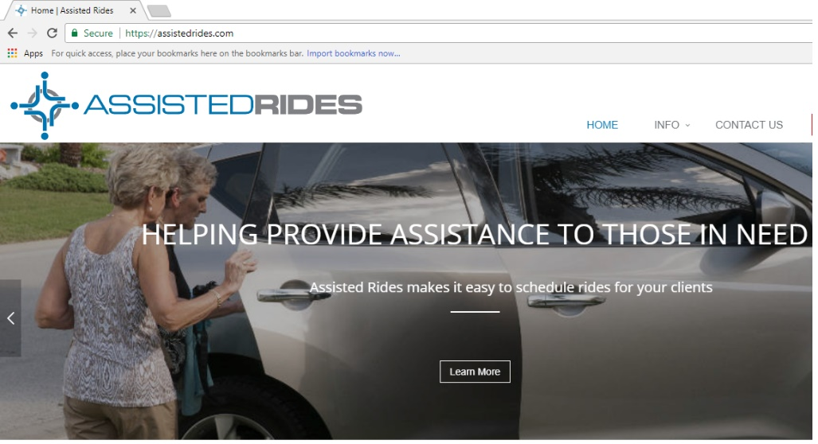
- Click on the word “LOGIN” at the top of the page.
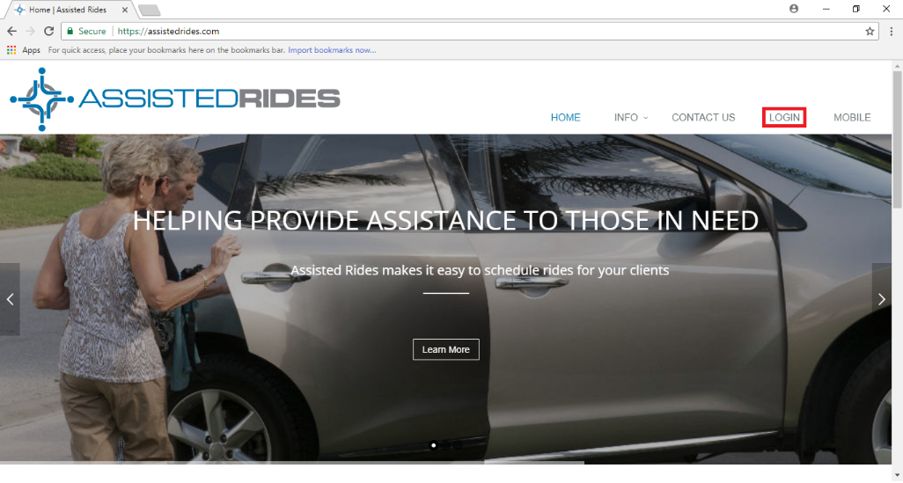
- NOTE: When you login for the very first time, you will see a “need password help?” option below the box where you enter your password; click this to create a password upon your first login. It will lead you to a screen that will request you to enter the User ID and verification code that you received in your email inviting you to use Assisted Rides. Remember to write down your password if/when you change it, so that you’ll have it in case you can’t remember it. Once you login, you will have an option to check the “remember me” box. If you do this, it will remember your password for you and the website will not make you re-login every time you visit. You should still have it written down somewhere just in case. You can also change your password at any time. Once you have completed the verification and creating your password, it will take you back to the log in screen.

- Enter your User ID and Password
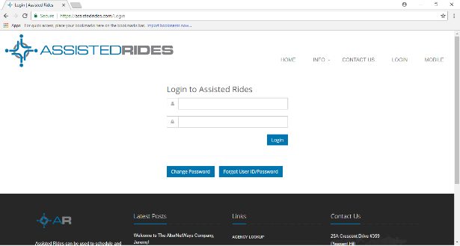
- Click “Login”.
- After you have logged in, you will see a list of “Available” rides on the right hand side of the screen or at the bottom of the ride info if you are on a mobile device. When you see a ride you are able to take, click on the word “Actions.”
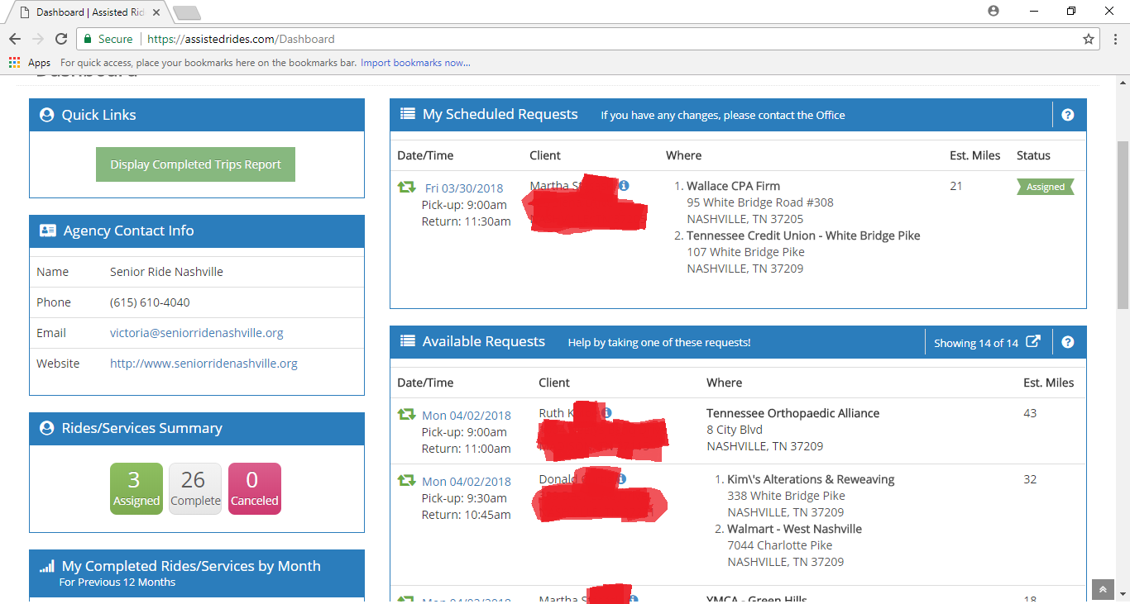
- Note: Any rides that you are scheduled for will appear at the top in a box marked “My Scheduled Rides.”
- To see the details of this ride, when you click on “Actions” button, it will have a drop down that allows you to “View Request Details”. You can also view the request details by clicking on the date displayed next to the ride. A new window will pop up with the trip details, pay special attention to the box “Trip Note” as these are notes from the office to help you know any necessary details about the rider, location or information about the trip. You can also click on “Click to Show Map” to see your home location, the home of the rider and the destination on a map.
- If this is a trip you can drive and the detail page is still opened, in the upper left-hand corner of the window or top of the page if on a mobile device, under “Actions”, you should click on the green “Assign Me as Driver.”
- If this is a trip you can drive and you have gone back to the list of all the available requests, click the “Actions” box to the right of the rider’s name or at the bottom for a mobile device. This will allow you to choose, “Assign me as a driver.”
- By clicking “Assign Me as Driver,” you are now responsible for this ride. Your screen will refresh for the schedule to reflect this. Once assigned and the screen has been refreshed, the information will move to the “My Scheduled Requests” box above the “Available Requests” box.
- If you made a mistake, and cannot take this ride, you can click on the word “Assigned” for the ride you took, and click on “Remove Me as Driver.” The page will refresh and move the ride back to the “Available Requests” box.
After You Have Completed Your Trip
- From your computer or mobile device, click on your internet browser of choice (Google Chrome, Internet Explorer, Mozilla Firefox, etc…) Then type www.assistedrides.com in the search bar at the top of your screen and log back into the website.
- Select the trip you completed and click on the date next to the ride.
- Towards the bottom of the new window on the left-hand side, it says “Update Status” and has a dropdown menu to the right. Click on the drop-down menu and select “Completed.” If you are on a mobile device, the “Update Status” will be a blue button under the “Actions” box above the ride details.
- If you need to change any of the mileage, enter the correct mileage into the textbox on the right.
- To report the actual time it took to complete the entire round trip, select the drop-down menu for “Time.” The list is in increments of 15 minutes. Select the closest time option.
- If you made any extra stops on the trip that were not on the manifest, select the box “Add Additional Stops” in the bottom left hand corner of the box. Enter the information for any additional stops that were made during your trip.
- In the box titled, “Driver Note”, please enter any information regarding your trip that the office would need to know or be interested in. Let us know what was good, what may have not gone as planned and any feedback from the experience.
- When finished, select “Save.” This is very important. If this step isn’t done, your work isn’t saved and the trip appears to have not been completed.
- When you click “save” the box will close and you are finished.
Congratulations on completing your trip with Assisted Rides!

